dSA ASSIGNMENT

UNIT-1

Q1) A company stores employee IDs in ascending order. Write a C program that accepts n employee
IDs, searches for a required ID using Binary Search, displays its position when found, reports
when it is absent, and counts the number of comparisons. Test the program for both successful
and unsuccessful searches.
SOL)
#include <stdio.h>

int main() {
int n, key, low, high, mid;
int comparisons = 0;
int found = 0;

printf("Enter the number of employee IDs: ");
if (scanf("%d", &n) != 1 || n <= 0) {
printf("Invalid input for number of employees.\n");
return 1;
}

int emp_ids[n];
printf("Enter %d employee IDs in ascending order:\n", n);
for (int i = 0; i < n; i++) {
scanf("%d", &emp_ids[i]);
}
printf("Enter the employee ID to search: ");
scanf("%d", &key);
low = 0;
high = n - 1;

while (low <= high) {
comparisons++;
mid = low + (high - low) / 2;

if (emp_ids[mid] == key) {
found = 1;
break;
} else if (emp_ids[mid] < key) {
low = mid + 1;
} else {
high = mid - 1;
}
}
if (found) {
printf("\nStatus: Success (ID found)\n");
printf("Position: %d (0-indexed: %d)\n", mid + 1, mid);
printf("Total comparisons: %d\n", comparisons);
} else {
printf("\nStatus: Failure (ID not found)\n");
printf("Total comparisons: %d\n", comparisons);
}

return 0;
}

OUTPUT:
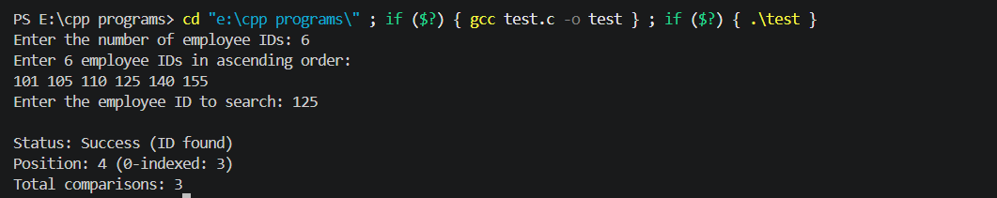

Q2) A teacher wants to arrange student marks in ascending order and also measure how much
rearrangement is necessary. Write a C program using Insertion Sort that accepts n marks, displays
the array after every pass, counts the total number of element shifts, and displays the final sorted
list and shift count.

SOL)
CODE:
#include <stdio.h>

int main() {
int n, i, j, key;
int shifts = 0;

printf("Enter the number of student marks: ");
if (scanf("%d", &n) != 1 || n <= 0) {
printf("Invalid input for number of marks.\n");
return 1;
}

int marks[n];
printf("Enter %d student marks:\n", n);
for (i = 0; i < n; i++) {
scanf("%d", &marks[i]);
}

printf("\nInitial array: ");
for (i = 0; i < n; i++) {
printf("%d ", marks[i]);
}
printf("\n\n--- Sorting Passes ---\n");

for (i = 1; i < n; i++) {
key = marks[i];
j = i - 1;
int shifted_in_pass = 0;

while (j >= 0 && marks[j] > key) {
marks[j + 1] = marks[j];
shifts++;
shifted_in_pass++;
j--;
}
marks[j + 1] = key;

printf("Pass %d: ", i);
for (int k = 0; k < n; k++) {
printf("%d ", marks[k]);
}
printf("(Shifts in this pass: %d)\n", shifted_in_pass);
}

printf("\n--- Final Results ---\n");
printf("Sorted marks in ascending order: ");
for (i = 0; i < n; i++) {
printf("%d ", marks[i]);
}
printf("\nTotal number of element shifts: %d\n", shifts);

return 0;
}

OUTPUT:
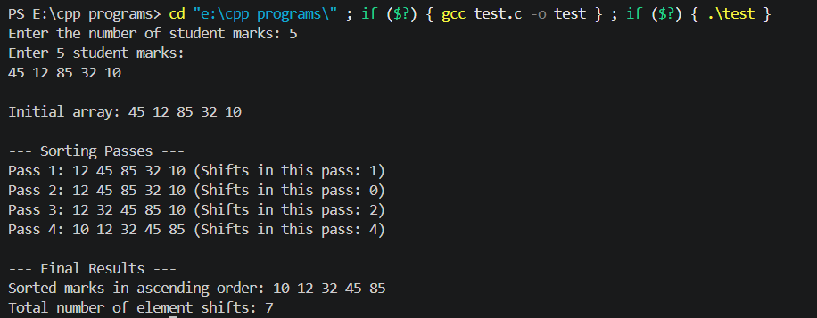

UNIT 2

Q1) An expression-processing application receives an arithmetic expression in infix form. Write a C
program using a stack to convert it to postfix form while correctly handling parentheses and
operator precedence for +, -, *, / and ^. Test the program using an expression containing multiple
operators and parentheses.
SOL)
CODE:
#include <stdio.h>
#include <string.h>
#include <ctype.h>

#define MAX 100

char stack[MAX];
int top = -1;

void push(char c) {
if (top < MAX - 1) {
stack[++top] = c;
}
}

char pop() {
if (top >= 0) {
return stack[top--];
}
return -1;
}

char peek() {
if (top >= 0) {
return stack[top];
}
return -1;
}

int precedence(char c) {
if (c == '^')
return 3;
else if (c == '*' || c == '/')
return 2;
else if (c == '+' || c == '-')
return 1;
else
return -1;
}

int isRightAssociative(char c) {
if (c == '^')
return 1;
return 0;
}

void infixToPostfix(char* infix, char* postfix) {
int i, j = 0;
int len = strlen(infix);
for (i = 0; i < len; i++) {
char c = infix[i];

if (isalnum(c)) {
postfix[j++] = c;
} else if (c == '(') {
push(c);
} else if (c == ')') {
while (top != -1 && peek() != '(') {
postfix[j++] = pop();
}
if (top != -1 && peek() == '(') {
pop();
}
} else {
while (top != -1 && precedence(peek()) >= precedence(c)) {
if (c == '^' && peek() == '^' && isRightAssociative(c)) {
break;
}
postfix[j++] = pop();
}
push(c);
}
}
while (top != -1) {
postfix[j++] = pop();
}
postfix[j] = '\0';
}

int main() {
char infix[MAX];
char postfix[MAX];

printf("Enter an infix expression: ");
scanf("%s", infix);

infixToPostfix(infix, postfix);

printf("Postfix expression: %s\n", postfix);

return 0;
}

OUTPUT:

Q2) A service centre uses a fixed-size request buffer in which released positions must be reused.
Write a C program to implement a Circular Queue using an array with insertion, deletion, display,
overflow and underflow operations. Demonstrate that positions freed after deletion can be reused
for new requests.
SOL)
CODE:
#include <stdio.h>
#define SIZE 5

int queue[SIZE];
int front = -1;
int rear = -1;

int isFull() {
if ((front == 0 && rear == SIZE - 1) || (front == rear + 1)) {
return 1;
}
return 0;
}

int isEmpty() {
if (front == -1) {
return 1;
}
return 0;
}

void insert(int value) {
if (isFull()) {
printf("Overflow! Request buffer is full. Cannot insert %d.\n", value);
return;
}
if (front == -1) {
front = 0;
rear = 0;
} else if (rear == SIZE - 1 && front != 0) {
rear = 0;
} else {
rear++;
}
queue[rear] = value;
printf("Successfully inserted request ID: %d\n", value);
}

void delete() {
if (isEmpty()) {
printf("Underflow! Request buffer is empty. No request to process.\n");
return;
}
printf("Processed and removed request ID: %d (Position %d freed)\n", queue[front], front);
if (front == rear) {
front = -1;
rear = -1;
} else if (front == SIZE - 1) {
front = 0;
} else {
front++;
}
}

void display() {
if (isEmpty()) {
printf("Request buffer is currently empty.\n");
return;
}
printf("Current Request Buffer: ");
int i = front;
if (front <= rear) {
while (i <= rear) {
printf("%d ", queue[i]);
i++;
}
} else {
while (i < SIZE) {
printf("%d ", queue[i]);
i++;
}
i = 0;
while (i <= rear) {
printf("%d ", queue[i]);
i++;
}
}
printf("\nIndices -> Front: %d, Rear: %d\n", front, rear);
}

int main() {
printf("--- Initializing Circular Queue of Size %d ---\n\n", SIZE);

printf("Step 1: Fill the queue completely\n");
insert(101);
insert(102);
insert(103);
insert(104);
insert(105);
display();

printf("\nStep 2: Attempt overflow insertion when full\n");
insert(106);

printf("\nStep 3: Delete two items to free positions at the beginning\n");
delete();
delete();
display();

printf("\nStep 4: Reuse freed positions by inserting new requests\n");
insert(106);
insert(107);
display();

printf("\nStep 5: Attempt overflow again with wrapped-around queue\n");
insert(108);

printf("\nStep 6: Empty the queue completely to test underflow\n");
delete();
delete();
delete();
delete();
delete();
delete(); // Triggers underflow

return 0;
}

OUTPUT: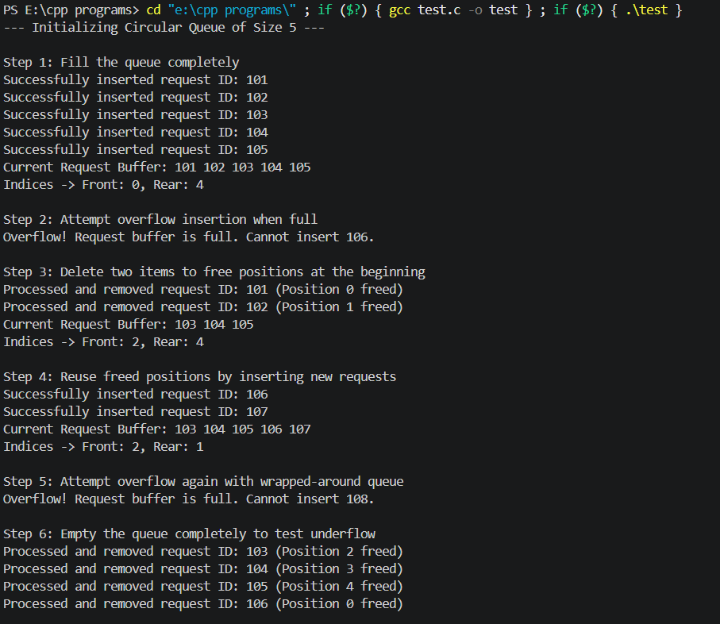

UNIT 3

Q1) A department maintains student roll numbers dynamically. Write a C program using a Singly
Linked List to create the list, insert at the beginning and end, search for a specified roll number,
delete a specified roll number, and display the updated list after each operation. Handle the case
when a requested roll number is not available.
SOL)
CODE:
#include <stdio.h>
#include <stdlib.h>

struct Node {
int roll_no;
struct Node* next;
};

struct Node* head = NULL;

void display() {
struct Node* temp = head;
if (temp == NULL) {
printf("The roll number list is currently empty.\n");
return;
}
printf("Current Roll Numbers: ");
while (temp != NULL) {
printf("%d -> ", temp->roll_no);
temp = temp->next;
}
printf("NULL\n");
}

void insertAtBeginning(int roll) {
struct Node* newNode = (struct Node*)malloc(sizeof(struct Node));
newNode->roll_no = roll;
newNode->next = head;
head = newNode;
printf("Inserted %d at the beginning.\n", roll);
display();
}

void insertAtEnd(int roll) {
struct Node* newNode = (struct Node*)malloc(sizeof(struct Node));
newNode->roll_no = roll;
newNode->next = NULL;

if (head == NULL) {
head = newNode;
} else {
struct Node* temp = head;
while (temp->next != NULL) {
temp = temp->next;
}
temp->next = newNode;
}
printf("Inserted %d at the end.\n", roll);
display();
}

void searchRoll(int roll) {
struct Node* temp = head;
int position = 1;
while (temp != NULL) {
if (temp->roll_no == roll) {
printf("Roll number %d found at position %d in the list.\n", roll, position);
return;
}
temp = temp->next;
position++;
}
printf("Roll number %d is not available in the list.\n", roll);
}

void deleteRoll(int roll) {
struct Node* temp = head;
struct Node* prev = NULL;

if (temp != NULL && temp->roll_no == roll) {
head = temp->next;
free(temp);
printf("Deleted roll number %d from the list.\n", roll);
display();
return;
}

while (temp != NULL && temp->roll_no != roll) {
prev = temp;
temp = temp->next;
}

if (temp == NULL) {
printf("Roll number %d not found. Deletion failed.\n", roll);
return;
}

prev->next = temp->next;
free(temp);
printf("Deleted roll number %d from the list.\n", roll);
display();
}

int main() {
int choice, roll;

while (1) {
printf("\n--- Student Roll Number Management Menu ---\n");
printf("1. Insert at Beginning\n");
printf("2. Insert at End\n");
printf("3. Search Roll Number\n");
printf("4. Delete Roll Number\n");
printf("5. Display List\n");
printf("6. Exit\n");
printf("Enter your choice: ");

if (scanf("%d", &choice) != 1) {
printf("Invalid input. Exiting.\n");
break;
}

switch (choice) {
case 1:
printf("Enter roll number to insert at beginning: ");
scanf("%d", &roll);
insertAtBeginning(roll);
break;
case 2:
printf("Enter roll number to insert at end: ");
scanf("%d", &roll);
insertAtEnd(roll);
break;
case 3:
printf("Enter roll number to search: ");
scanf("%d", &roll);
searchRoll(roll);
break;
case 4:
printf("Enter roll number to delete: ");
scanf("%d", &roll);
deleteRoll(roll);
break;
case 5:
display();
break;
case 6:
printf("Exiting program.\n");
exit(0);
default:
printf("Invalid choice! Please choose between 1 and 6.\n");
}
}

return 0;
}

OUTPUT:
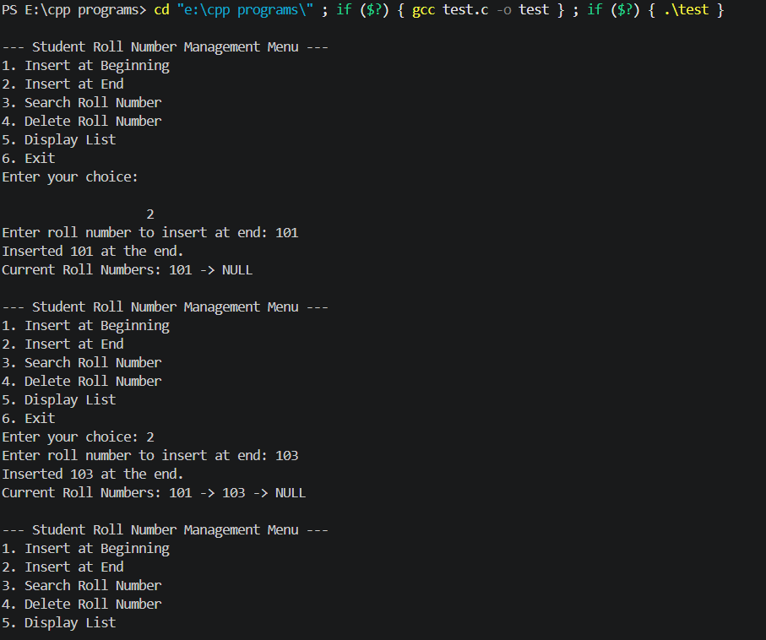
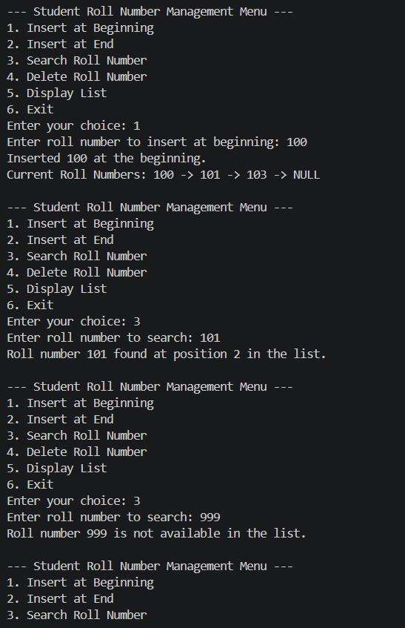
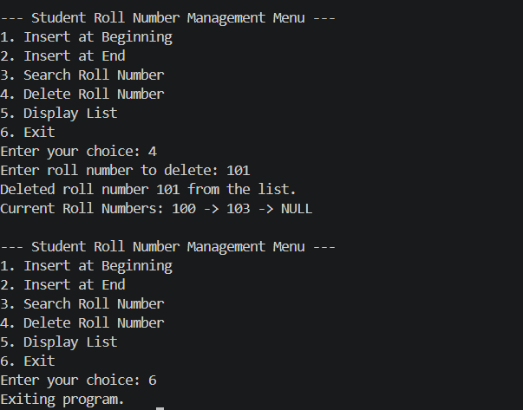

Q2) Develop a C program for a Doubly Linked List representing a sequence of web pages visited by a
user. The program should insert a new page, move forward and backward, delete a specified
page, and display the pages from first-to-last and last-to-first while handling beginning and end
conditions correctly.
SOL)
CODE:
#include <stdio.h>
#include <stdlib.h>
#include <string.h>

struct Node {
char url[100];
struct Node* prev;
struct Node* next;
};

struct Node* head = NULL;
struct Node* current = NULL;

void displayForward() {
struct Node* temp = head;
if (temp == NULL) {
printf("History is empty.\n");
return;
}
printf("History (First to Last): ");
while (temp != NULL) {
if (temp == current) {
printf("[Current: %s] <-> ", temp->url);
} else {
printf("%s <-> ", temp->url);
}
temp = temp->next;
}
printf("NULL\n");
}

void displayBackward() {
struct Node* temp = head;
if (temp == NULL) {
printf("History is empty.\n");
return;
}
while (temp->next != NULL) {
temp = temp->next;
}
printf("History (Last to First): ");
while (temp != NULL) {
if (temp == current) {
printf("[Current: %s] <-> ", temp->url);
} else {
printf("%s <-> ", temp->url);
}
temp = temp->prev;
}
printf("NULL\n");
}

void visitPage(char* url) {
struct Node* newNode = (struct Node*)malloc(sizeof(struct Node));
strcpy(newNode->url, url);
newNode->next = NULL;
newNode->prev = NULL;

if (head == NULL) {
head = newNode;
current = newNode;
} else {
struct Node* temp = current->next;
while (temp != NULL) {
struct Node* nextNode = temp->next;
free(temp);
temp = nextNode;
}
current->next = newNode;
newNode->prev = current;
current = newNode;
}
printf("Visited: %s\n", url);
displayForward();
}

void moveBack() {
if (current != NULL && current->prev != NULL) {
current = current->prev;
printf("Moved backward to: %s\n", current->url);
} else {
printf("You are already at the first page. Cannot go back further.\n");
}
displayForward();
}

void moveForward() {
if (current != NULL && current->next != NULL) {
current = current->next;
printf("Moved forward to: %s\n", current->url);
} else {
printf("You are already at the last page. Cannot go forward further.\n");
}
displayForward();
}

void deletePage(char* url) {
struct Node* temp = head;
while (temp != NULL && strcmp(temp->url, url) != 0) {
temp = temp->next;
}

if (temp == NULL) {
printf("Page '%s' not found in history.\n", url);
return;
}

if (temp == head) {
head = temp->next;
if (head != NULL) {
head->prev = NULL;
}
} else {
temp->prev->next = temp->next;
if (temp->next != NULL) {
temp->next->prev = temp->prev;
}
}

if (current == temp) {
if (temp->next != NULL) {
current = temp->next;
} else if (temp->prev != NULL) {
current = temp->prev;
} else {
current = NULL;
}
}

free(temp);
printf("Deleted page '%s' from history.\n", url);
displayForward();
}

int main() {
int choice;
char url[100];

while (1) {
printf("\n--- Browser History Management Menu ---\n");
printf("1. Visit New Page\n");
printf("2. Move Backward\n");
printf("3. Move Forward\n");
printf("4. Delete Specific Page\n");
printf("5. Display Forward (First to Last)\n");
printf("6. Display Backward (Last to First)\n");
printf("7. Exit\n");
printf("Enter your choice: ");

if (scanf("%d", &choice) != 1) {
printf("Invalid input. Exiting.\n");
break;
}

switch (choice) {
case 1:
printf("Enter URL to visit: ");
scanf("%s", url);
visitPage(url);
break;
case 2:
moveBack();
break;
case 3:
moveForward();
break;
case 4:
printf("Enter URL to delete: ");
scanf("%s", url);
deletePage(url);
break;
case 5:
displayForward();
break;
case 6:
displayBackward();
break;
case 7:
printf("Exiting program.\n");
exit(0);
default:
printf("Invalid choice! Please choose between 1 and 7.\n");
}
}

return 0;
}
OUTPUT:
